Ryan Hoskin
XXX-01-3343
Computer Science 150
Homework # 1

Problem 1:
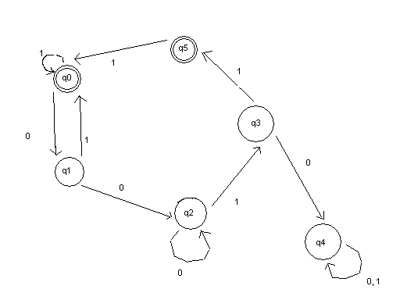

q0: This is the initial state. If the string contains a one it will return to itself, 0 will continue on to the next state. Q0 is a final state for if the string contains a combination of 00 and ends with more than two consecutive ones it will be true.

q1: Here if the string contains one zero followed by a one it will return back to the initial state, forcing it to either end or continue until it has two zeros followed by two ones.

q2: Now that there have been two consecutive zeros, this will repeat until it hits a one, where it will then check for whether there are two following ones.

q3: If there were more than two consecutive zeros followed by one – zero, the sting is not a part of the language, and it moves on to q4, where it will end. Otherwise, it is a part of the language.

q4: Anything that ends up at q4 is not a part of the language.

q5: If a string contained two consecutive zeros followed by two or more ones, it can exit here if it ends or will move back to q0.

Problem 2:

The DFA here describes a language that contains zeros consecutively in multiples of twos and/or ones consecutively in multiples of three.

Q0: The initial and only final state. If the first letter of the string is 0, it will head off to q1, otherwise it will go down to q2. If the string ends on q0, it conforms to the previously stated conditions and will exit.

Q1: At point q1, the string must contain 00 in order to have any chance of being a subset of the language; otherwise, it will move to q3, where there is no possibility of it being a subset of the language.

Q2: q2 is another pivot point of the language. Here the string must be two consecutive ones, otherwise it will head to q3.

Q3: q3 is the state of no escape. If a string has proceeded to q3 then there is no possibility of it being a subset of the language described by this DFA.

Q4: The string must contain three consecutive zeros to return back to the final state, otherwise it will go to q3.

