www.tvondemand.com
Business Model
MGT 280
Group 2
Ryan Hoskin
Kimberly Jenn
Allen Huang
Table of Contents

Service Overview 3
Moore/McKenna Value Statement 4
We believe that our value is based upon the following statement: 4
Value Chain 5
Old Value Chain 5
New Value Chain 6
Segmentation 6
Sustainable Competitive Advantage 7
Analysis of Competition 8
• Potential entrants. 8
• Suppliers’ bargaining power 9
• Consumers bargaining power 9
• Substitutes 9
• Rivalry. 9
Customer Dynamics 9
Market Growth 10
Microeconomics 10
Product Positioning 11
Old Model 11
Channel Issues (Table B) 11
Location issues 13
Firm and Industry Structure 13
Resource System (VRIO) 14
Financial Model (Revenue stream) 15
Opportunities for Success 15
What are the critical success factors? 15
What is the outlook (probability) for success? 16

Service Overview
I frantically look around my house for my Pink Floyd CD but it is nowhere to be found. Is it under the couch; no. Is it behind the stereo; no. This is just one of the many problems with having your music stored on a compact disc. I still remember when I was a freshman living in the dorms at the University of California, Riverside when I first heard about digital music and MP3’s. It was so convenient to download any song I wanted, at my convenience. Today MP3’s have completely displaced the demand for CD’s. No longer are people willing to pay outrageous prices for media when they can get it for a much cheaper price.
It is this same type of technology that is going to revolutionize the way that users view television shows and movies. In today’s fast pace lifestyle people are not willing to wait until 9 o’clock to watch their favorite TV show. They want to watch it when they can, where they can.
We propose a new idea: television on demand. We would provide a web portal, www.tvondemand.com, in which users would be able to watch television shows, movies and sports, at their convenience. Our users would be able to login through our website and watch their favorite shows at any time. Our technology would provide users with streaming, high quality video from almost any internet connection.
Our product is aimed to replace the standard view-not-at-your-leisure television programming. We will develop sustainable relationships with broadcasting and production studios so that we can promote and serve their product to a wider and ever-increasing market.
We will have several market segments which we will aggressively seek. Pretend that a football fan is seeking to watch their favorite team on a Sunday afternoon. Why should they have to pay an outrageous fee for a cable “football package” when they can watch their game through our service for a much more competitive rate. Imagine a Seinfeld fan wanting to watch their favorite episode but it may not be on for another six months. With our service they would be able to watch their favorite programming at their leisure for a small subscription fee. This is the technology that will revolutionize the way that television is experienced.
Beyond the standard subscription revenue for our product we have devised a technology in which advertisements will be strategically placed within our software. When users are loading (buffering) their video streams they will be shown advertisements that directly relate to their specific interests. This concept is similar to the technology used by some of the most advanced Meta search engines in use today. For example, Google.com uses similar technology when a user sends an inquiry through their search database. When a user enters a search query their database will pull up specific pages along with ads that are related to the content provided by the search results. Likewise, our service would display small, unobtrusive advertisements that would not negatively affect the users on demand experience.

Moore/McKenna Value Statement

We believe that our value is based upon the following statement:
“For anyone that watches television who wants to watch specific shows at specific times our product is a provider of television shows on demand. Unlike traditional programming our product allows customers to the shows they want to watch, when they want.”

Value Chain
Currently the value chain is four levels deep. Shows are produced by either production companies or by broadcasting company studios. Broadcasting companies, such as NBC or ABC, then create a program schedule that they believe will be the most advantageous for their consumers and distribute the video to communication companies such as Charter Communications, Cox Digital Cable or Adelphia Communications.

Old Value Chain

Production
Companies

Broadcasting
Companies

Distribution
Companies

End User
(Customer)
We are the missing link in this value chain. Looking at the diagram below one can see that we provide the link between the production studios and broadcasting companies and go straight to the end user, making the communication companies obsolete.
One might ask, “Why don’t the communication companies do this? They already provide on demand services.” The answer is simple: they can’t. The reason that communication companies are not able to provide such services is that their data communications infrastructure is not setup to do so. What makes our services different is that we are not making the guarantee on the quality of service through the broadband connection that they provide. We are guaranteeing that the data is streamed from our servers, through the internet, to the location at the speed in which the end user is most capable of receiving. This relieves our company of the duties that come along with the transmission of the signal; we pass this on to the end user’s telecommunications provider (i.e. their broadband provider).

New Value Chain
www.tvondemand.com
Create
Unique
TV viewing
Process
(Online &
On-Demand)
Exclusive
Contracts
With
Production
Companies

Production
Companies

Broadcasting
Companies

Internet
Service
Providers

End User
(Customer)
Exclusive
Contracts
With
Broadcasting
Companies

Segmentation
When considering what target market we are going to approach, we must ask the question “Who needs video on demand”? Our response is based upon specific demographics that have the need to see specific content at specific times. We have broken our demographic into several sections, some of which we predict in the short-term will be high-demand customers; others will be low-demand customers. Looking at the chart below one can see that sports enthusiasts will be one of our main target segments, along with movie fans. Followers of sports and movies are likely to be high-return consumers that require content at their convenience. Outside of these two groups we look to attract consumers that are faithful to specific television shows.
Segmentation Matrix

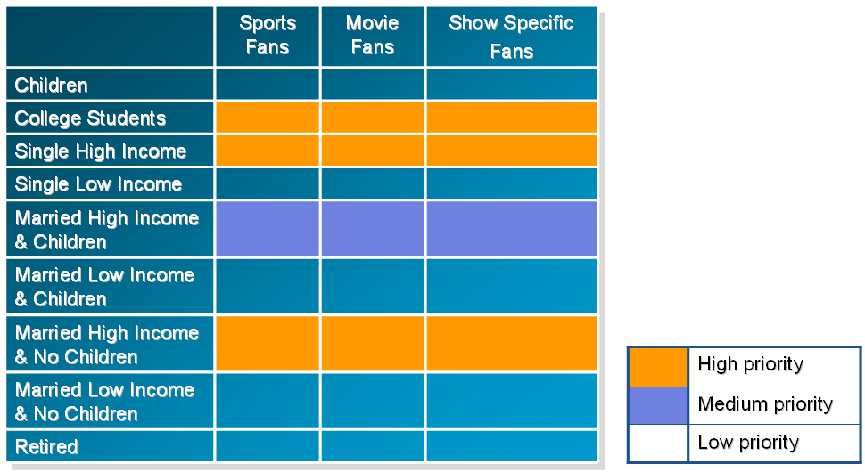

Sustainable Competitive Advantage
We are poised to strike on a new an unexploited market; our technology is the wave of the future and we are the first to adapt. Just as digital music and the MP3 disrupted the music industry, TV on demand will disrupt the television programming industry. Through our strategic partnerships with production and broadcasting companies we will be able to dominate the market.
Broadcasting and production companies will likely adapt to our technology for one simple reason: we can expand their market segment significantly and we can provide their product to their target consumers in a whole new way. This is the key to our success and our sustainability. Once we have gained support from the television content providers it is extremely difficult for competitors to enter our market. Our competitive advantage is derived from our relationships with providers. Partners such as NBC, FOX, ABC and others will provide us with a high quality of brand name recognition that cannot be beat. This will give us and will provide us with long-term sustainability and will bring us to the next level of service for our customers.

Analysis of Competition
To analyze the competition of tvondemand.com, we applied Porter’s five forces model. Table A shows the five forces facing our venture.
Table A -- Porter’s Five Forces

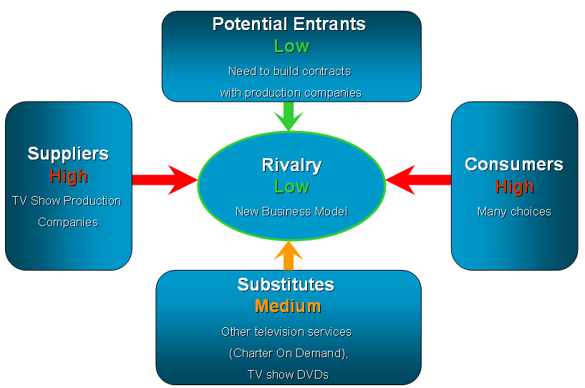

- Potential entrants: To enter this market, a company first needs to develop well-functioned software. It may be time-consuming and expensive. What’s more important is that the company needs to negotiate and cooperate with TV show production companies.
- Suppliers’ bargaining power: A lot of TV production companies are very powerful because they make some famous TV shows. Some of TV shows are produced by big broadcasting companies, such as HBO. In other words, suppliers have high bargaining power in this market.
- Consumers bargaining power: There are a lot of choices for customers including different media, such as traditional TV, computers or different broadcasting companies. Therefore, customers have high bargaining power.
- Substitutes: Consumers still can watch TV shows through traditional programming, TiVo and DVDs. However, when compared to the alternatives TV on demand is more convenient.
- Rivalry: tvondemand.com is a new business model, so there are no other direct competitors.

Customer Dynamics
Unmet Need: Before tvondemand.com, the methods consumers can watch TV shows include watching television when the shows are on, recording TV shows through a DVR (TiVo), or getting TV show DVDs. For some people whose working time is not fixed, waiting in front of the television is not always an option. Recording TV programs is just inconvenient. Additionally, not every TV show is available on DVD. Our service will be able to fulfill all of these unmet needs.

Market Growth
- Fast Connection: For a high quality of service we recommend using a broadband connection when connecting to our server and today broadband connectivity is becoming much more widely available for the consumer population. The number of Americans using fast Internet connections doubled from 2001 through late 2003. In urban areas, 40.4 percent of households used fast connections; only 24.7 percent of rural users did. These figures indicate a huge market growth for our service within the near future.
- Watching TV online—With the growing number of cable operators assaulting telecom business with the introduction of VOIP, telecommunication companies are will likely adopt TV over Internet Protocol in an effort to entice customers into purchasing bundled broadband offerings.

Microeconomics
According to http://www.itfacts.biz/index.php?id=P1644 website, Multimedia Research Group Estimates there will be 15.6 million TVIP viewers by 2007, up from a few hundred thousand today. The average American adult watches nearly five hours of television per day. If we conservatively ball park today’s TVIP viewers as 200,000 and estimate that they watch 3 hours of television per day, the total annual number of hours of television watched would be 217 million. Since our company is the pioneer of TVIP, it is moderate to estimate that we are able to capture 20 percent of market share which is estimated to be 43.4 million hours per year. If we hypothetically charge ten cents per hour, our annual revenue will be $4.34 million. We estimate that by 2007 we will have gained at least 30 percent of the market share yielding annual revenue of $512.5 million. The volume of TVIP viewers will be definitely high. However, the profitability depends on the price we charge and the costs of delivering our services. The price will be determined depending on demand and price elasticity of our customers. At this point of time, it is difficult to determine, but we do know that price is inelastic to people who are in our target market segments. As far as costs are concerned, our costs are most likely fixed costs of the contracts we negotiate with production studios and the development costs for software. However, the costs will likely be higher if the market is larger in the future. The profitability, therefore, is largely depending on number of viewers after breakeven point.

Product Positioning

Old Model: When watching TV, we think the main products consumers get are the physical TV programs (80%). Consumers also can get some services provided by communication companies, such as cable installation and trouble shooting (10%). Information that the communication companies provide include TV show schedule at a specific channel and TV guide at their websites (10%).
New Model: tvondemand.com can provide much more services (40%) than the old model because customers can watch any TV shows in the website any time. Since it provides a larger part of service, the percentage of physical product is lower. Besides, at the beginning of tvondemand.com, it’s difficult to provide as various TV shows as the regular communication companies can do. tvondemand.com provides more information than the regular communication companies by integrating all the information offline and online.
Market Maker: tvondemand.com creates unique TV viewing process and makes exclusive contracts with production companies. In other words, it builds a bridge directly between suppliers and consumers, and creates a new market of TV viewing.
Seller and Buyer Agent: By replacing the role of communication companies, tvondemand.com is also a seller agent. In the other hand, tvondemand.com is also a buyer agent because consumers can access TV programs without TV communication companies. However, some TV communication companies also provide broad-bandwidth service, such as Charter Communications. Therefore, tvondemand.com cannot totally replace the role of the buyer agent.
Fulfillment: tvondemand.com provides on-line TV viewing services and fulfills disintermediation. However, tvondemand.com cannot control the Internet communication companies and the quality of connection. tvondemand.com cannot guarantee the fulfillment of the Internet connection.

Table B Tvondemand.com’s Channel

Location issues

The location is in the forefront of consumer mind which only is not easily assessed in term of its values and accessibility. The second best location may be the broadcasting company websites where we can to bring the traffic into our website because most of viewers go to broadcasting company websites to view information of sitcoms. Creating awareness is not an easy task because there are many factors that involved with all units within the vertical value chain. For example, downloading our products depends on not only our great service but also on the popularity of the television sitcoms or drama. Fortunately, there is no direct competition in conveying shows through computers to our consumers. Without any direct head-on competition, the opportunities to partner with other companies such as Starbucks, Walmarts, or AOL are great in this virgin marketplace. The costs of partnering with these companies might not necessarily be expensive. However, the costs of creating awareness in consumers’ heads required fairly large amount of money up front when we begin the business. The cost is primary on advertising our company in being known as the option of viewing television shows via computer even exists.

Firm and Industry Structure

Our business is in a pure play environment where business only exists on the internet. There are no brick and mortar elements required in our business; the only tangible requirement is the storage size of our company for our inventory: television shows. On the industrial structure level of our business, the suppliers include production studios, such as MGM, Paramount, Spelling Studios. On the downstream of the value chain to the consumer perspectives, intermediaries between our industry and the consumers are cable companies and ISPs who are the only instruments to reach the consumers’ television and computers. From the firm structure perspective, the picture is quiet the same comparing to the industry level except for the downstream intermediaries are ISP’s. As the firm structure shows, our company heavily depends on ISP’s to deliver our product to the viewers. Yet, ISP’s bargaining power is not strong enough to overpower our company since the market is flooded with ISP’s.

Resource System (VRIO)

Since we are still in the design phase the critical resources from the human, physical, financial organizational aspects are difficult to evaluate. However, we can evaluate the company by its inherent advantages. The competitive advantages and resources of our company are the ability to display television shows at customers’ convenience, the quality of picture and “clean” file transfers.
The ability to display television shows at customers’ convenience is valuable and rare but it is not difficult to imitate. However, since we are one of the first company launch this specific service, we will be the first exploiting this advantage organizationally. The exclusive contracts with production studios are very valuable, rare, and difficult to imitate. This is our main source of a sustainable competitive advantage. It is extremely difficult for a competitor to develop the relations with production and broadcasting studios once we have gained a significant portion of the market share. Our ability to exploit this resource will be difficult to predict as it is highly dependent upon our ability to establish relations with the content providers. Quality of picture and clean file transfer are valuable but not rare and not difficult to imitate. Again it is not the quality of the file or the ability to display video on demand that gives us our competitive advantage. Our competitive advantage stems from our exclusive relationships with content providers which will allow us to display select programming to our users which is something that is not available on the market today.

Financial Model (Revenue stream)

Our main revenue sources come from advertising and subscriptions. The advertising revenue will be strategically placed so as to not interfere with the users viewing experience. Advertising revenues will not be our main focus. Advertisements will be placed on our website, during video start-up and during buffer download. We will implement pricing strategies that will maximum the subscription revenues by filling the consumer surplus. The shareholder value is perceived from our ability to provide the best experience, widest assortment of programming and most personalized content.

Opportunities for Success

What are the critical success factors?

Our critical success factors are the development of relationships with the production and broadcasting companies and the ability to display TV on demand. The sustainability of the company also rests on our ability to fully exploit our resources and to balance the revenue streams and cost of buying the rights of broadcasting the television shows. As previously stated there is an unmet demand and there are un-serviced customers in the market. We have entered the marketplace at a critical time that allows for us to grab a high percentage of the market share early. If we are able to successfully establish the relationships previously described there is a high probability of success.

What is the outlook (probability) for success?

The probability for success will be high during our early growth period. Our long-term sustainability and prosperity is dependent upon our ability to maintain our supplier relations and provide a high quality of service to our customers. We feel that once we are established within the marketplace the chances of success are extremely high. As we build our brand equity it will be unwise for our suppliers to part ways with us and it will be extremely difficult for new competitors to enter the marketplace.

References:
http://www.itfacts.biz/index.php?id=P1644
http://www.itfacts.biz/index.php?id=P2087
http://story.news.yahoo.com/news?tmpl=story&cid=528&e=1&u=/ap/20041122/ap_on_hi_te/wired_nation

