Jacob Bieber
Bryce Foster
Ryan Hoskin
Vasiliki Zafiris
EXECUTIVE SUMMARY

Kay Jan, Inc. has been a family owned business for over 50 years and is a business that has centered itself in rural communities providing quality John Deere agriculture equipment and service. There are four dealerships on the Eastern plains of Colorado and 1 in Western Kansas. Kay Jan purchased and began operations at the Flagler dealership in 2000. Over the course of four full years the Flagler dealership has lost over $275,000 in operating revenues, not including the cost of the store. The company turnover rate has been approximately three employees per year.

The predominant current issue that the Flagler dealership company is facing is its ability to create a sustainable competitive advantage. Companies in small towns, such as Flagler, face distinctive problems. A dominant problem that small towns face is the pace of life in their area. What amplifies this problem is that many companies in these small towns have to cannibalize from the same work force.

Kay Jan’s success comes mainly from its internal resources and capabilities. Kay Jan has many strengths that have allowed them to stay competitive in an uncertain environment. Theirs strengths are their leadership, employee development, customer service, their close proximity to buyers, and from having multiple dealerships. These strengths are the basis of their advantage within the industry. Kay Jan also must overcome weaknesses mainly related to their Flagler dealership, the main source of weakness within the company. The Flagler dealership suffers from poor customer perception due to high employee turnover. The company as a whole also lacks an updated mission statement and has relatively high employee training costs.

Kay Jan’s opportunities come from the changing structure of the industry due to consolidation and societal changes within the entire nation, with the increase in de-urbanization. There are also many threats that Kay Jan has to prepare for. They include the consolidation of the customer base and the shrinking rural labor pool. Other threats come from the John Deere’s corporate strategy and changing federal government policies.

The agricultural industry itself does not look attractive at this time. Large corporate manufacturers wield immense power over both suppliers and buyers. Hence, Kay Jan has very little bargaining power with their supplier, John Deere. Kay Jan’s buyers have moderate power, as they have some choice over who they buy from and are generally knowledgeable about the products. However, limited supply helps to offset most of the power that they do have. Substitutes to Kay Jan at this time are low, but have the potential, in the future, to increase substantially. Rivalry in the industry is moderate, with 3 main manufacturers controlling most of the supply. From the dealership perspective, the rivalry can be seen as a little more intense, as they are competing not only with dealers of competing products, but with other John Deere dealers as well. The threat of entry is relatively low as there are high entry barriers to the industry for dealerships.

Conditions in the macro-environment also will have an effect on Kay Jan. Kay Jan must be aware of these in order to plan more precisely for the future and ensure future success. They includes things such as technological and market changes, governmental issues and policies that associated with agriculture and other related fields, changes in social patterns and lifestyle changes, demographic changes, and local events.

Our first recommendation is for Kay Jan to focus on local recruitment, recruiting at local high schools to inform the local population of the advantages of working for Kay Jan and the available local employment opportunities. The way to begin this cultivation is to develop a strong, positive presence in the community. Developing programs with the local high school, we recommend that the store work in conjunction with the Vo. Ag. instructor, Jim Hannebaum. He would then bring a full class into the shop during the winter months, when shop space is available, to work on a 6-8 week project, as a way to introduce the Kay Jan organization to the most number of potential employees, at a younger age, as well as develop a stronger presence in the community, possibly persuading existing members to come join the organization.

Our second recommendation is for Kay Jan to look at college recruitment as a source of labor and qualified candidates. Colleges and Universities throughout the state have various programs dedicated to Agricultural Studies and Agricultural Resource Economics. Potentially, a mutually beneficial relationship between colleges and universities and Kay Jan would be a key advantage in the labor market. One university’s career center said that creating a relationship between the dealerships and the University would be very beneficial. Kay Jan will be drawing educated, dedicated employees who are already interested in staying in the agricultural fields.

Our third recommendation is an alternative way for Kay Jan to sell its inventory and increase their inventory turnover on new and used equipment. It involves the use of an auction website called ironplanet.com.
HISTORY
Kay Jan, Inc. has been a family owned business for over 50 years and is a business that has centered itself in rural communities providing quality John Deere agriculture equipment and service. Jeff and Martha Bieber purchased the single location with a total 4 employees in 1972 in the small town of Cheyenne Wells, CO from Jeff’s parents, Skip and Edna Bieber. Since then, the company has grown to five locations and has over 80 employees. There are four dealerships on the Eastern plains of Colorado and 1 in Western Kansas. Withstanding many economic, internal, and external obstacles three of the five dealerships have become lucrative agriculture equipment sales and service centers where two have been struggling since their purchase including Kay Jan, Inc Flagler, CO.
Flagler’s John Deere agriculture dealership has been a part of the community for approximately 50 years and has had three previous owners before the Biebers. In a town with a population of 600 the major providers of the community are in the agricultural field. Farmers are highly reliant on equipment and service in the day-to-day productivity in their own business. The John Deere dealership has been a provider of income and employment to Flagler for many years, but because the town is so small there are many problems encountered that larger towns do not face.
Jeff and Martha purchased and began operations at the Flagler dealership in 2000. Over the course of four full years the Flagler dealership has lost over $275,000 in operating revenues, not including the cost of the store. The company turnover rate has been approximately three employees per year. That number might not seem very excessive, however, when an organization employs only seven or eight people the company is looking at a turnover rate of approximately 40%. Without a strong leader that can oversee the daily operations the dealership has struggled to generate profit in any department as well as train and keep quality, long-term employees.
Quality dealerships are not impossible to have in small rural towns though. Two good examples are in the Kay Jan, Inc. company, Cheyenne Wells, CO and Leoti, KS. With a bolstering population of 1,200 at Cheyenne Wells the dealership has consistently performed well and has generally remained at the top of Kay Jan’s dealerships in terms of productivity. The Leoti, KS location has been a part of the company for ten years now and has shown immense improvement in productivity in the past years actually surpassing the largest dealership, Fort Morgan, in profit. Leoti’s strong customer service has been recruited eighty percent of their employee base from an area surrounding a town of 1700 people.
CURRENT ISSUES
The predominant current issue that the Flagler dealership company is facing is its ability to create a sustainable competitive advantage. Most agricultural businesses are fairly simple, yet they are able to create some sort of competitive advantages through the people within the organization and they way those individuals have the interpersonal skills to effectively lead each dealership into profitability and success. Dealerships that can successfully create some sort of differentiation that distinguishes them from local and regional competitors have qualified leaders and an effective support staff, which emphasizes follow through with all of its customers. Although most farmers do shop on price, customer service is a key factor in deciding with which dealership to do business. We are able to see just how important leaders and capable employees are when we compare the five dealerships. Building strong customer service is vital to long-term sustainability of this organization. Bringing in strong human resources is a direct way to create sound service in an industry where loyalty can be price driven. Companies in small towns, such as Flagler, face distinctive problems. A dominant problem that small towns face is the pace of life in their area. What amplifies this problem is that many companies in these small towns have to cannibalize from the same work force.
Furthermore, small companies, such as Kay Jan Inc. sometimes lack the infrastructure to deal with business beyond their regions. Their value chains are limited to the suppliers (John Deere) to Fulfillment (customer pick up their machinery, or have it delivered) with no intermediation or real link to outside traffic into their stores. Kay Jan can aid the Flagler dealership in mediating some of its loss in revenues by creating external inputs to sell used equipment. This way the smaller stores can be imbued with the resources necessary to grow without necessarily drawing out retained earnings from other stores.

INTERNAL ANALYSIS
Kay Jan SWOT Analysis: Resources and Capabilities
SWOT analysis is a very effective managerial tool for identifying a company’s strengths and weaknesses, and of examining the opportunities and threats that they face. Completing and utilizing SWOT analysis help a company to focus on the activities and areas where there are significant strengths and which show the greatest opportunities for the future. Kay Jan management needs to look at the strengths of the company and assess if these strengths open up any opportunities. Alternatively, looking at the company’s weaknesses is also important since they can and evaluate them to determine if opportunities can arise by eliminating those weaknesses.
Strengths:
Leadership
Human capital, particularly leadership and direction from the top is a key strength at Kay Jan Inc. All organizational resources are driven specifically by the top leadership in the company. The owners and managers of the company always exude positive energy and optimism and they are constantly stressing camaraderie and trust amongst their employees and the local community.
Employee Development
Employee recruiting, training, and development are crucial strengths within Kay Jan Inc. The company is willing to recruit, train, and motivate employees for various positions within the company. They believe a long-term relationship with employees is vital to the success of any company.
Customer Service
Another important strength evident in Kay Jan Inc. is their large presence in the community. The Cheyenne Well dealership has been Kay Jan owned for 53 years; the Fort Morgan dealership has been part of the local community for almost 20 years. Community presence and longevity is a very important strength, particularly in the agricultural business, since farmers’ buying behavior has a stronger link to individuals or a local company than it does to mass retail or national chains.
Close Proximity to Buyers
Since all the dealerships are located in small towns, a key strength is the fact that the owners, managers, and employees themselves also live in close proximity to the dealerships that they work in. They have first hand knowledge of the local communities, and the issues that many of the citizens of those communities (including the farmers) may face on a day-to-day basis. This is an important strength because any issues can be mitigated immediately and problems can be solved quickly and efficiently. Furthermore, being located close to your buyers allows you to really know and understand who your customers are and how to serve them
Multiple Dealerships
Kay Jan is a multiple-dealership company which allows for them to hedge risk in rough times. This means that they are not impacted by the agricultural conditions of one small area. If Leoti, Kansas is having economic issues related to drought or other natural disasters, such as tornados, the company can look to the other stores for revenue streams.
Weaknesses:
Poor Customer perception in the Flagler dealership
As mentioned above, a main strength of the company is the fact that many of the managers and owners live in close proximity of the dealerships that they work in, with one exception: the Flagler dealership. Of the five Kay Jan dealerships, the one located in Flagler has the disadvantage of being the one in the smallest town, with a population of around 650 people. This causes many issues in employee recruitment and inevitably leads to employee turnover and lack of quality customer service follow through. This is due to the fact that employees who have been uprooted from larger towns to smaller ones have had a difficulty time viewing employment in Flagler as long-term. As a result, customers are reluctant to do business at that dealership since they have to deal with a different person every time they need something from the store. Kay Jan must continue to develop habits and skills to change this perception into a positive direction.
Lack of an updated Mission Statement/Vision Statement
First, and foremost, at the embryonic stage of any strategic management process lays a company’s mission or vision statement. At the very least, a mission statement depicts the reasons why a company is in business and will provide the groundwork for all other business decisions going forward. For Kay Jan Inc., the strategic issue of lacking a competitive advantage in the Flagler dealership perhaps begins with lack of values or statements that portray the major goals and objectives. The most costly, and sometimes, most integral part of a company’s value chain lies in how the support function, its human resources, aids in facilitating the movement of the company’s primary activities (such as marketing/sales, and customer service) in the direction the company would like it to take. Without a clear mission or vision, it is difficult to shape and direct the actions and behaviors of employees. Although Kay Jan Inc has a mission statement, it has yet to be updated. The mission statement has been the same since 1979. Aside from updating the mission statement, management needs to ensure that the vision of the company is being disseminated to all employees, particularly those in the Flagler dealership.
Employee experience and skill at the Flagler dealership is limited
The talent pool of the local community is more like a “Petri dish”. Although it makes economic sense to seek employees from the local community to fulfill any necessary human resource needs that a company desires, the job pools in small towns tend to be too homogeneous, not providing the necessary variety and skills sets that are necessary to conduct business. Qualified, experienced talent is usually found in larger towns or in less rural locations. On the same token, if Kay Jan Inc. is able to find an employee who meets the employment standards, getting that person to move from a larger town to a small town and then stay there becomes tedious.
High employee training cost
If the company is able to find someone who is competent enough and who has the potential to possess the right skill sets to become a full-time employee, Kay Jan Inc will pay for their training. Although it is a major benefit for the company to have experience employees, the problem lies in the fact that those employees do not always become long-term.
Opportunities:
Developing Relationships
Kay Jan has opportunities in developing good relationships with large farm operations. If they can become the exclusive provider, or one of the top providers of equipment while at the same time offer them good service and a good experience, they can build the company’s reputation and could attract other large operations, even small ones. Furthermore, the consolidation of suppliers can mean fewer competitors.
De-urbanization of America
De-urbanization of America can also be an opportunity worth pursuing. “Glorification of big cities prevailed for the better part of this century” but this is not longer the case. Higher costs of living, and a lower quality of life, not to mention traffic congestion in many urban locations has caused many young, working-age individuals to become jaded by city life and have considered moving into smaller, less populated towns. Corporations, like Kay Jan Inc. must find a way to reach out to those considering migration to smaller towns. This can create new growth in the local communities and “replenish a community’s tax coffers”.
Threats:
Consolidation of the customer base
Larger, corporate farms will sprout up, leaving fewer and fewer family farms, and larger operations. There will be the same amount of land space, just fewer customers. The issue here is that if smaller farms do become highly consolidated, there is potential for these large corporate farmers to skip the middle man, the dealership, and purchase equipment directly from John Deere.
Shrinking rural labor pool
This is not only a weakness, but is also a threat. If the rural communities begin to change their way of life a leave those communities, Kay Jan will have a lot of its invested capital lost.
John Deere’s Processes:
John Deere’s just-in-time inventory process has made it difficult for dealerships to get inventory on short notice. This causes a shortage of available equipment for the dealerships to sell in good economic times. This inevitably causes too much dealer-to-dealer trading and negotiating of equipment than was needed in the past. This tends to dilute profit margins and can cause higher levels of dealership rivalry.
Additional Threats:
Additional threats include the fact that there is potential for the reduction of government subsidies. This may leave farmers with little money to buy equipment, as they may hold onto their current equipment longer. Furthermore, sowing industry growth for agricultural equipment in U.S. and Europe is a problem as agriculture shrinks in developed countries. The potential consolidation of suppliers (John Deere), passing distribution costs down to the dealers is also a threat. This will cause dealers to have fewer places to draw from when supply is low. Currently, due to John Deere’s JIT inventory, dealerships can rely on each other for support. If consolidation for suppliers keeps growing, there is less “fall back” for the dealerships. Availability of raw materials to suppliers could affect prices of equipment, affecting dealerships ability to buy equipment, as well as their margins on the sale of the equipment.

As an addendum to SWOT analysis, other internal analysis, such as a VRIO analysis, allows a company to research its resources and capabilities so that it can take advantage of opportunities. A resources/capabilities analysis has been compiled to break down Kay Jan’s resources (physical, social capital, human capital, organizational abilities, and financial) to aid in determining how valuable, rare, imitable those resources are and whether or not the organization exploits these resources. If a company can bundle resources in a positive way, it can create a competitive advantage and allow the company to gather its resources and capabilities to respond to environmental changes (FIGURE 1; FIGURE2).
EXTERNAL ANALYSIS
PORTER’S FIVE COMPETITIVE FORCES
MACROENVIRONMENTAL ISSUES

The current situation in the agricultural industry (specifically agricultural dealerships) can be depicted through Porter’s Five Competitive Forces. The degree of supplier power, the availability of substitutes, the bargaining power of the buyers, the barriers to entry and the degree of rivalry (competition) are good ways to illustrate what the external environment looks like and can help managers create strategic plans for the future:
Supplier Power – High
Kay Jan Inc.’s one and only supplier is John Deere International, who supplies them with all of the new agricultural tractors as well as all of the replacement parts that are used to service them. In recent years John Deere has switched to a just-in-time (JIT) inventory strategy to cut costs. What this has done for Kay Jan has made it difficult to acquire equipment on short notice, as John Deere has minimal amounts of inventory in stock at any given time. This causes problems when a potential customer has needs that must be satisfied quickly and Kay Jan cannot deliver because their supplier cannot fulfill their orders in an expedited manner. Since Kay Jan has an emphasis on a high level of customer service, it becomes hard to meet your customers demands without help from your supplier. Why has John Deere moved to a JIT strategy? Simple, by cutting inventory costs it makes their financials look better – something that their investors demand of them. As a public company John Deere is always working for their owners, the shareholders, whose intentions are likely not in line with Kay Jan’s.
Additionally, bargaining power of the supplier is high because, unlike other industries, there is little potential for Kay Jan Inc. to vertically integrate. Kay Jan, as stated earlier, is highly dependent on John Deere as their supplier and it would be nearly impossible for them to just start manufacturing their own agricultural equipment (barriers in doing this are almost limitless, from high entry costs to economies of scale). Furthermore, the size of the supplier is very high and since they factually hold a monopoly to the buyers (dealerships) then unless the buyers form some sort of coalition, then they have no real bargaining power.
The limited number of agricultural equipment suppliers also limits the power of the suppliers. Dealerships theoretically can switch from one supplier to another; however, the likelihood that this would happen is very slim. Wherever there is currently a John Deere dealership there is also a Case and Agco dealership close by. This would very difficult for a dealership to switch since those suppliers would not allow multiple dealerships in the same geographic area.
Substitutes – Low but dangerous
Currently, there is no substitute for farmers going to a dealership direct to purchase their equipment. One threat in the future, as a potential result of the consolidation of many farmers and increase in corporate farms, will result in John Deere and other manufacturers of agriculture selling direct. This will produce a substitute location for which buyers (farmers and the like) can purchase their equipment. On the up-side, there is no substitute for agricultural equipment. Farmers cannot use alternative equipment to harvest grain; it is a combine or nothing, the era of donkey plows are over.
Buyer Power – Moderate
A significant threat to Kay Jan dealerships is the possibility of customers traveling to another regional dealership to make a purchase. Even though there can only be a limited number of John Deere dealerships within a certain area, there are still many other dealerships of other companies which can service the needs of Kay Jan’s target market. Overall customers have a wide variety of choices when choosing an agricultural equipment dealer. Furthermore, although most farmers are rather informed about the equipment and the options available to them, their bargaining power is limited due to the fact that supply is limited. Since no real substitutes exist for agricultural equipment, and there are limited locations that buyers can go to get their equipment serviced, this illustrates that although buyers are fairly informed, they have no real power.
Future power of buyers is forecasted to increase as the size and concentration of the buyers, relative to the suppliers, continues to increase. The more and more farmers consolidate means that there is a smaller number of buyers and the bigger the size of the purchases that they make. This increases the cost of losing one buyers,
Barriers to Entry – High
There are relatively high barriers to entry as a new newcomer to the industry. High setup costs, high exit cost (sunk costs) high customer switching costs, economies of scale and lack of community connections are huge hurdles that a newcomer would face, making entering this industry not very lucrative.
The initial costs of starting an agricultural equipment dealer are significant. Franchise costs, inventory costs and other general costs are very high. In order to start your own agricultural equipment dealer you must have the facilities, the space and the resources to fulfill the demands of your customers. Dealers must have new equipment for customers to purchase as well as have the capability of maintaining and servicing equipment for their customers.
The majority of the players in this industry have been established and integrated into their communities for long periods of time. Throughout their existence in these communities, they have been able to form lasting relationships with their customers, a competitive advantage not easily mimicked by a newcomer to the industry. Customers are highly unlikely to switch from their current provider to a new provider as they have already invested so much into their current provider in terms of equipment and servicing.
Low differentiation between the products also will make it difficult for newcomers to enter and distinguish themselves and the credible threat of response from incumbents will make the industry very unattractive to enter. Economies of scale are also a barrier. Many of the incumbents have large multi-dealerships that allow them to hedge costs. Newcomers would essentially have to open three of four stores in a wide geographic area to compete and keep their costs down. Furthermore, the absolute cost advantage of the current dealerships means that they have had the opportunity to purchase a lot of their materials, even land, when it was less expensive and have the time to establish economies of learning that newcomers simply do not have.
Rivalry – Moderate
Within the agricultural equipment industry, there are three main competitors: Case New Holland, Agco, and John Deere. Each of these manufacturers sells equipment that is an exact substitute of John Deere products. For Kay Jan the potential of a customer purchasing a tractor from a competitor is an ever-present threat. To combat this Kay Jan has put an emphasis on a high level of customer service which will pay dividends when a customer requires servicing or maintenance to be done on their tractors. If you treat the customer well, they will be more inclined to not only service their vehicle at your location, they will likely come back in the future for their next purchase. Another driving factor for customers’ choice of dealerships is because there is a low switching cost when switching from one manufacturer to another. In the rural town environment that the Kay Jan dealerships are located, the relationships that have been built over time between a customer and the dealer is extremely strong; however, they are easily replaced. Customers value relationships, but they value dollars more.
MACROECONOMIC ISSES:
THE BUSINESS ENVIRONEMENT AT KAY JAN
THE FLAGLER STORE

To further elaborate on external issues, and to avoid some shortcomings of utilizing only Porter’s Five Forces for evaluating outside threats, a quick look at the macroeconomic issues that affect the agricultural dealerships is vital. The business environment for any company, small and large, includes all external influences that will inevitably play a role in the way a firm makes and executes decisions. For Kay Jan Inc., it is important that we are able to make a distinction between those environmental forces that play limited roles to those that are very vital to the success of the company. Utilizing the Five Forces Model to gauge the external environment is very important; however, since static assumptions are sometimes made, we have to ensure that we are gauging potential competitor reactions and how the industry will likely perform in the future. One key factor in the agricultural industry that we have to consider, for example, is the speed at which the industry is changing. We discussed how there are clear signs of industry consolidation, both at the supplier end and at the buyer end. Glancing at macro-economic forces may help us assess the rate at which we may anticipate these changes (FIGURE 3). By completing an overview of macroeconomic issues that Kay Jan Inc., faces, management can see opportunities can come from such things, which include:
- Technological and market changes and that can occur on a very broad or narrow scale
- Governmental issues and policies that associated with agriculture and other related fields
- Changes in social patterns and lifestyle changes
- Demographic changes
- Local Events

RECOMMENDATIONS and IMPLEMENTATIONS
After completing analysis, both internal and external, including Kay Jan’s resources and capabilities, we have developed a strategic set of recommendations that will help them create a sustainable competitive advantage in the Flagler dealership and ultimately, over other agricultural dealerships in the area. We do not believe that any of these recommendations are mutually exclusive from one another; however, we do believe that if all are implemented, the success of the company will see longer-term benefits.
Recommendation/Implementation #1: Local Recruitment
Addressing the major issue of finding quality, long-term employees to develop a sustainable competitive advantage would be to cultivate from the community direct. Many of the high quality employees in the Kay Jan organization grew up in the community that they now work in. At the Cheyenne Wells, CO location, 44% of the individuals in the organization grew up in the general area and almost all of the employees grew up in rural, mid-west towns. At Leoti, KS the number of employees that grew up in the surrounding areas is 75%. It is not unusual for young members of a rural community to leave for education or new experiences for a number of years but it is also common for them to return to the area they grew up. For those in the community that are more suited for vocational trades, particularly diesel mechanics and equipment assembly, it is important to plant the seed that Kay Jan is an excellent place to work and a location that they can cultivate their talents and a carrier. As an example of the exceptional employees that grew up in the community, we look at the top three producing salesmen in the corporation, Russ Ball from Cheyenne Wells, Robbie Berning from Leoti, and Doug Wulf from Fort Morgan.
The way to begin this cultivation is to develop a strong, positive presence in the community. Kay Jan has always done an excellent job in supporting their communities by sponsoring the FFA and 4H participants. In Flagler directly, Kay Jan has donated money every year to the Vo.Ag. department at the High School so they can fashion belt buckles that are awarded to excellent students at the end of the year.
Another thing Kay Jan has implemented with the high Schools is a junior/senior employment opportunity for any willing and able student to work after school and during breaks in the parts department or as a shop assistant. But these few students only get to see what happens in the dealership as an entry-level employee.
To show a larger number of the Flagler High School students the possible employment opportunities, we recommend that the store work in conjunction with the Vo.Ag. instructor, Jim Hannebaum. He would then bring a full class into the shop during the winter moths, when shop space is available, to work on a 6-8 week project, like inspecting a diesel engine or learning how a seeder works. This would give the students the ability to explore John Deere’s agricultural equipment under some supervision and with a mechanics expertise, as well as introduce them to the different employment opportunities at the Kay Jan organization, specifically in Flagler. Although there are legal procedures that the organization will need to take, it is a way to introduce the Kay Jan organization to the most number of potential employees, at a younger age, as well as develop a stronger presence in the community, possibly persuading existing members to come join the organization.

Recommendation/Implementation #2: College Recruitment
To further address customer service as a distinctive competency that will give the Flagler store a competitive advantage, Kay Jan needs to find employees who have a keen understanding of the industry and long-term economic impact that future circumstances may bring to the agricultural community. Aside from drawing in employees from a local city, Kay Jan Inc. has the benefit of being situated in an area of Colorado that allows them to take advantage of Colleges and Universities that offer degrees in Agricultural studies and Agricultural Resource Economics. We contacted several individuals from Colorado State University and received positive feedback from all of them. Mr. Brett Beal, from CSU’s career center said that creating a relationship between the dealerships and the University would be very beneficial. Once a connection is established between the Agricultural Science Career Center and Kay Jan Inc. the two can create a mutually beneficial relationship where Kay Jan will be drawing educated, dedicated employees who are already interested in staying in the agricultural fields. Furthermore, Professor Norm Dalsted from the Department of Agricultural and Resource at CSU states that the University would have students who may be interested in employment opportunities with John Deere dealerships. What was most compelling from Professor Dalsted’s comment is that although John Deere, from a corporate standpoint, interviews on their campus, local dealerships have yet to do so. This would introduce Kay Jan Inc. as a first mover into college recruitment.
Recommendation/Implementation #3: Online Sales
While Kay Jan as a whole is doing well, stores such as the Flagler dealership are not. In our analysis we have discovered that the company as a whole incurs large costs by holding used inventory. Used machines come from customers who choose to trade-in their previous agricultural equipment when purchasing a newer machine. The problem is that this used merchandise quickly becomes a burden on the company. Maintenance fees and depreciation are the main issues. Used inventory frequently takes over a year to resell, sometimes taking even longer. During this time the machines become dilapidated and require upkeep. Fluids must be changed, the machines must be clean and the engine must be kept up. What this equates to is extra expenses for a tractor that is depreciating in value every day. In order to remain competitive Kay Jan must figure out how to cut costs or increase cash flow.
We have discovered a solution that will cut inventory costs and increase revenues on used equipment: www.ironplanet.com. Ironplanet.com is an online auction that specializes in heavy equipment and is actually the third largest equipment auction company in the nation. They provide an online marketplace with a worldwide reach. Auctions are held every other Thursday, and unlike traditional auction houses the seller’s items does not have to move.
The two obvious concerns over selling in an online auction are that no one will purchase something of this magnitude online, and if they do they will never pay full price. To alleviate these issues IronPlanet has a network equipment inspectors, whom average 23 years of heavy equipment experience, to “perform prompt, reliable and standardized inspections” throughout the country. The inspection includes ratings and comments on key systems and components. Functional tests are also performed during the inspection. Additionally between 15 and 25 photos of the machine are taken, giving the customer a sense of “being there” before making a purchase. By bringing in outside sources to certify the quality of the machinery being sold, IronPlanet is able to build a sense of trust with the customer which generates great auction results.
To sell used machinery on IronPlanet will take little effort on Kay Jan’s part. It takes only a few minutes to create an account. Selling an item is just as easy. An online form with general information on the machinery and contact information is filled out and gets automatically sent to a regional inspector who then schedules a time with you for an inspection. The inspection takes place at your facility, and the report is listed on the auction for all to see (Figure 5). Once the item has been purchased, the buyer must send full payment within three days to IronPlanet. IronPlanet handles all of the collections, takes its 6-8% cut and deposits the money directly into the seller’s bank account. The buyer is then responsible for transporting the equipment. All together it takes almost no effort on Kay Jan’s part to sell equipment through IronPlanet, and they are able to turn equipment around in a period of three to five weeks instead of one to two years. This cuts down on the high maintenance costs and depreciation that the company has eaten in the past when selling used equipment.
Overall IronPlanet appears to be a great outlet for Kay Jan. As a new link in Kay Jan’s value chain (Figure 6) IronPlanet provides exposure to a much larger audience and creates a link between buyer and seller. By expanding to the online marketplace Kay Jan will be one step ahead of its competition and will be able to take advantage of its larger revenue stream and cost savings.
Questions for Jake:
- Average lifespan on a piece of equipment
- Maintenance costs?
- Margins on used equipment

APPENDIX
Figure 1.
TANGIBLE

Financial
Physical
HUMAN
Specialized skills Knowledge
Communication
Motivation
INTANGIBLE

Technology
Reputation
Culture
Resources
Org
Capabilities
Industry
Key Factors

Competitive
Advantage

Strategy
Source: Grant, Robert M. Contemporary Strategy Analysis 3rd ed. Blackwell Publishers 1998

FIGURE 2.

FIGURE 3. MACROECONOMIC ISSUES
Sociocultural

INDUSTRY
ENVIRONMENT
Political/Legal
Economic
Technological
Demographic

FIGURE 4. IRONPLANET.COM ITEM VIEW
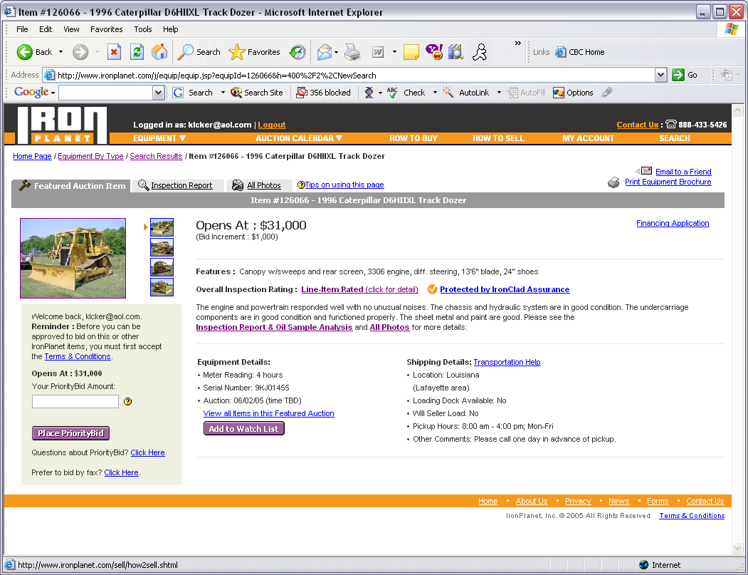

FIGURE 4. IRONPLANET.COM INSPECTION REPORT
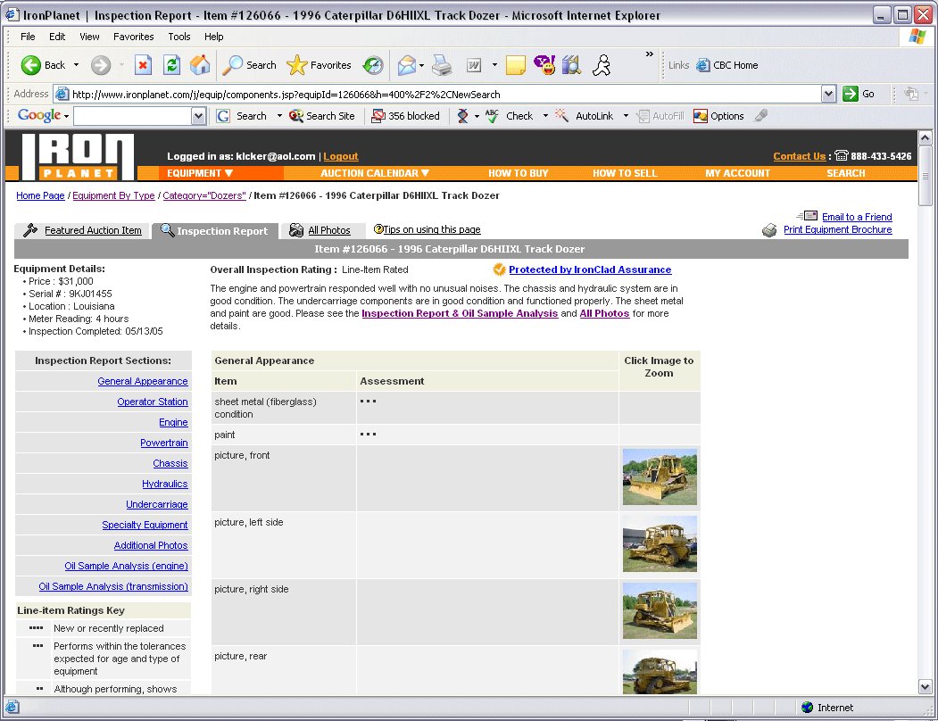
FIGURE 6. NEW VALUE CHAIN
Fulfillment:
Customer

Buying & Leasing
Old Value Chain
New Value Chain
Supplier
John Deere
Manufactures Equip
& it is distributed to
dealerships
Retailer
Pricing, Storing
Billing, Delivering
Handling returns

Suppliers

John Deere
Manufactures Equip
& it is distributed to
dealerships
Retailer/
Dealerships
Pricing
Storing
Billing
Delivering
Handling
returns
Fulfillment:
Customer

Buying
Leasing

Online Sales
Customers have
The option of buying
Used equipment
Online
New Value Chain
Old Value Chain

Heenan, David A. The New Corporate Frontier: The Big Move to Small Town, U.S.A. McGraw-Hill, Inc. 1991. Page 2
Heenan, David A. The New Corporate Frontier: The Big Move to Small Town, U.S.A. McGraw-Hill, Inc. 1991. Page 3

